keepalived安装文档

# 安装环境

su - root

yum -y install kernel-devel*

yum -y install openssl-*

yum -y install popt-devel

yum -y install lrzsz

yum -y install openssh-clients

yum -y install libnl libnl-devel popt

# 安装keepalived

## 上传keepalived安装文件

1、cd /usr/local/src/

2、mkdir keepalived

3、cd keepalived/

4、wget <http://www.keepalived.org/software/keepalived-1.2.15.tar.gz> 或者 rz 上传

## 解压

1、tar -xvf keepalived-1.2.15.tar.gz

2、cd keepalived-1.2.15

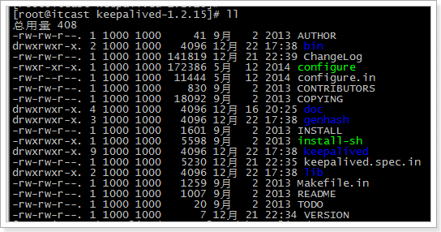

## 安装keepalived

1、cd keepalived

2、执行配置命令

./configure

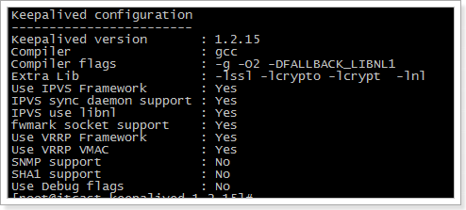

3、编译

make

4、安装

make install

5、拷贝执行文件

cp /usr/local/sbin/keepalived /usr/sbin/

6、将init.d文件拷贝到etc下,加入开机启动项

cp /usr/local/etc/rc.d/init.d/keepalived /etc/init.d/keepalived

7、将keepalived文件拷贝到etc下，加入网卡配置

cp /usr/local/etc/sysconfig/keepalived /etc/sysconfig/

8、创建keepalived文件夹

mkdir -p /etc/keepalived

9、将keepalived配置文件拷贝到etc下

cp /usr/local/etc/keepalived/keepalived.conf /etc/keepalived/keepalived.conf

10、添加可执行权限

chmod +x /etc/init.d/keepalived

## 加入开机启动：

chkconfig --add keepalived

chkconfig keepalived on

# 配置日志文件

1.将keepalived日志输出到local0：

vi /etc/sysconfig/keepalived

KEEPALIVED_OPTIONS="-D -d -S 0"

2.在/etc/rsyslog.conf里添加:

local0.* /var/log/keepalived.log

3.重新启动keepalived和rsyslog服务：

service rsyslog restart

service keepalived restart

# 打开防火墙的通讯地址

iptables -A INPUT -d 224.0.0.18 -j ACCEPT

/etc/rc.d/init.d/iptables save